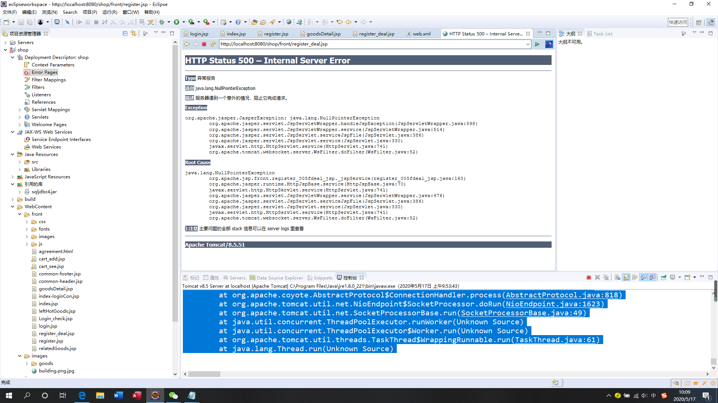
五月 17, 2020 9:53:44 上午 org.apache.catalina.startup.VersionLoggerListener log
信息: Server.服务器版本: Apache Tomcat/8.5.51
五月 17, 2020 9:53:44 上午 org.apache.catalina.startup.VersionLoggerListener log
信息: 服务器构建: Feb 5 2020 22:26:25 UTC
五月 17, 2020 9:53:44 上午 org.apache.catalina.startup.VersionLoggerListener log
信息: 服务器版本号(：8.5.51.0
五月 17, 2020 9:53:44 上午 org.apache.catalina.startup.VersionLoggerListener log
信息: OS Name: Windows 10
五月 17, 2020 9:53:44 上午 org.apache.catalina.startup.VersionLoggerListener log
信息: OS.版本: 10.0
五月 17, 2020 9:53:44 上午 org.apache.catalina.startup.VersionLoggerListener log
信息: 架构: amd64
五月 17, 2020 9:53:44 上午 org.apache.catalina.startup.VersionLoggerListener log
信息: Java 环境变量: C:\Program Files\Java\jre1.8.0_221
五月 17, 2020 9:53:44 上午 org.apache.catalina.startup.VersionLoggerListener log
信息: JVM 版本: 1.8.0_221-b11
五月 17, 2020 9:53:44 上午 org.apache.catalina.startup.VersionLoggerListener log
信息: JVM.供应商: Oracle Corporation
五月 17, 2020 9:53:44 上午 org.apache.catalina.startup.VersionLoggerListener log
信息: CATALINA_BASE: D:\eclipseworkspace\.metadata\.plugins\org.eclipse.wst.server.core\tmp0
五月 17, 2020 9:53:44 上午 org.apache.catalina.startup.VersionLoggerListener log
信息: CATALINA_HOME: E:\Tomcat\apache-tomcat-8.5.51
五月 17, 2020 9:53:44 上午 org.apache.catalina.startup.VersionLoggerListener log
信息: Command line argument: -Dcatalina.base=D:\eclipseworkspace\.metadata\.plugins\org.eclipse.wst.server.core\tmp0
五月 17, 2020 9:53:44 上午 org.apache.catalina.startup.VersionLoggerListener log
信息: Command line argument: -Dcatalina.home=E:\Tomcat\apache-tomcat-8.5.51
五月 17, 2020 9:53:44 上午 org.apache.catalina.startup.VersionLoggerListener log
信息: Command line argument: -Dwtp.deploy=D:\eclipseworkspace\.metadata\.plugins\org.eclipse.wst.server.core\tmp0\wtpwebapps
五月 17, 2020 9:53:44 上午 org.apache.catalina.startup.VersionLoggerListener log
信息: Command line argument: -Djava.endorsed.dirs=E:\Tomcat\apache-tomcat-8.5.51\endorsed
五月 17, 2020 9:53:44 上午 org.apache.catalina.startup.VersionLoggerListener log
信息: Command line argument: -Dfile.encoding=UTF-8
五月 17, 2020 9:53:44 上午 org.apache.catalina.core.AprLifecycleListener lifecycleEvent
信息: The APR based Apache Tomcat Native library which allows optimal performance in production environments was not found on the java.library.path: [C:\Program Files\Java\jre1.8.0_221\bin;C:\WINDOWS\Sun\Java\bin;C:\WINDOWS\system32;C:\WINDOWS;C:/Program Files/Java/jre1.8.0_221/bin/server;C:/Program Files/Java/jre1.8.0_221/bin;C:/Program Files/Java/jre1.8.0_221/lib/amd64;C:\Program Files (x86)\Common Files\Oracle\Java\javapath;C:\Program Files (x86)\Intel\iCLS Client\;C:\Program Files\Intel\iCLS Client\;C:\Windows\system32;C:\Windows;C:\Windows\System32\Wbem;C:\Windows\System32\WindowsPowerShell\v1.0\;C:\Program Files (x86)\Intel\Intel(R) Management Engine Components\DAL;C:\Program Files\Intel\Intel(R) Management Engine Components\DAL;C:\Program Files (x86)\Intel\Intel(R) Management Engine Components\IPT;C:\Program Files\Intel\Intel(R) Management Engine Components\IPT;C:\Program Files (x86)\NVIDIA Corporation\PhysX\Common;C:\WINDOWS\system32;C:\WINDOWS;C:\WINDOWS\System32\Wbem;C:\WINDOWS\System32\WindowsPowerShell\v1.0\;C:\WINDOWS\System32\OpenSSH\;C:\Program Files\NVIDIA Corporation\NVIDIA NvDLISR;C:\Program Files\Java\jdk1.8.0_221\bin;D:\Program Files (x86)\SQL Sever\130\Tools\Binn\;D:\Program Files\SQL Sever\130\Tools\Binn\;D:\Program Files\SQL Sever\130\DTS\Binn\;D:\Program Files\SQL Sever\Client SDK\ODBC\130\Tools\Binn\;D:\Program Files (x86)\Microsoft SQL Server\130\Tools\Binn\;D:\Program Files\Microsoft SQL Server\130\Tools\Binn\;D:\Program Files (x86)\Microsoft SQL Server\130\DTS\Binn\;D:\Program Files\Microsoft SQL Server\130\DTS\Binn\;D:\Program Files\Microsoft SQL Server\Client SDK\ODBC\130\Tools\Binn\;D:\Program Files (x86)\Microsoft SQL Server\150\DTS\Binn\;"E:\Tomcat\apache-tomcat-8.5.51\lib;E:\Tomcat\apache-tomcat-8.5.51\bin";E:\SQLite;C:\Users\14846\AppData\Local\Microsoft\WindowsApps;;E:\BaiduNetdiskDownload\eclipse\eclipse-jee-oxygen-R-win32-x86_64\eclipse;;.]
五月 17, 2020 9:53:44 上午 org.apache.coyote.AbstractProtocol init
信息: 初始化协议处理器 ["http-nio-8080"]
五月 17, 2020 9:53:44 上午 org.apache.tomcat.util.net.NioSelectorPool getSharedSelector
信息: Using a shared selector for servlet write/read
五月 17, 2020 9:53:44 上午 org.apache.catalina.startup.Catalina load
信息: Initialization processed in 1183 ms
五月 17, 2020 9:53:44 上午 org.apache.catalina.core.StandardService startInternal
信息: Starting service [Catalina]
五月 17, 2020 9:53:44 上午 org.apache.catalina.core.StandardEngine startInternal
信息: Starting Servlet Engine: Apache Tomcat/8.5.51
五月 17, 2020 9:53:45 上午 org.apache.jasper.servlet.TldScanner scanJars
信息: 至少有一个JAR被扫描用于TLD但尚未包含TLD。 为此记录器启用调试日志记录，以获取已扫描但未在其中找到TLD的完整JAR列表。 在扫描期间跳过不需要的JAR可以缩短启动时间和JSP编译时间。
五月 17, 2020 9:53:45 上午 org.apache.coyote.AbstractProtocol start
信息: 开始协议处理句柄["http-nio-8080"]
五月 17, 2020 9:53:45 上午 org.apache.catalina.startup.Catalina start
信息: Server startup in 754 ms
com.microsoft.sqlserver.jdbc.SQLServerException: 对象名 'tb_Member' 无效。
at com.microsoft.sqlserver.jdbc.SQLServerException.makeFromDatabaseError(SQLServerException.java:196)
at com.microsoft.sqlserver.jdbc.SQLServerStatement.getNextResult(SQLServerStatement.java:1454)
at com.microsoft.sqlserver.jdbc.SQLServerStatement.doExecuteCursored(SQLServerStatement.java:1824)
at com.microsoft.sqlserver.jdbc.SQLServerStatement.doExecuteStatement(SQLServerStatement.java:760)
at com.microsoft.sqlserver.jdbc.SQLServerStatement$StmtExecCmd.doExecute(SQLServerStatement.java:685)
at com.microsoft.sqlserver.jdbc.TDSCommand.execute(IOBuffer.java:4026)
at com.microsoft.sqlserver.jdbc.SQLServerConnection.executeCommand(SQLServerConnection.java:1416)
at com.microsoft.sqlserver.jdbc.SQLServerStatement.executeCommand(SQLServerStatement.java:185)
at com.microsoft.sqlserver.jdbc.SQLServerStatement.executeStatement(SQLServerStatement.java:160)
at com.microsoft.sqlserver.jdbc.SQLServerStatement.executeQuery(SQLServerStatement.java:620)
at com.tools.ConnDB.executeQuery(ConnDB.java:75)
at org.apache.jsp.front.register_005fdeal_jsp._jspService(register_005fdeal_jsp.java:161)
at org.apache.jasper.runtime.HttpJspBase.service(HttpJspBase.java:70)
at javax.servlet.http.HttpServlet.service(HttpServlet.java:741)
at org.apache.jasper.servlet.JspServletWrapper.service(JspServletWrapper.java:476)
at org.apache.jasper.servlet.JspServlet.serviceJspFile(JspServlet.java:386)
at org.apache.jasper.servlet.JspServlet.service(JspServlet.java:330)
at javax.servlet.http.HttpServlet.service(HttpServlet.java:741)
at org.apache.catalina.core.ApplicationFilterChain.internalDoFilter(ApplicationFilterChain.java:231)
at org.apache.catalina.core.ApplicationFilterChain.doFilter(ApplicationFilterChain.java:166)
at org.apache.tomcat.websocket.server.WsFilter.doFilter(WsFilter.java:52)
at org.apache.catalina.core.ApplicationFilterChain.internalDoFilter(ApplicationFilterChain.java:193)
at org.apache.catalina.core.ApplicationFilterChain.doFilter(ApplicationFilterChain.java:166)
at org.apache.catalina.core.StandardWrapperValve.invoke(StandardWrapperValve.java:199)
at org.apache.catalina.core.StandardContextValve.invoke(StandardContextValve.java:96)
at org.apache.catalina.authenticator.AuthenticatorBase.invoke(AuthenticatorBase.java:543)
at org.apache.catalina.core.StandardHostValve.invoke(StandardHostValve.java:139)
at org.apache.catalina.valves.ErrorReportValve.invoke(ErrorReportValve.java:81)
at org.apache.catalina.valves.AbstractAccessLogValve.invoke(AbstractAccessLogValve.java:688)
at org.apache.catalina.core.StandardEngineValve.invoke(StandardEngineValve.java:87)
at org.apache.catalina.connector.CoyoteAdapter.service(CoyoteAdapter.java:343)
at org.apache.coyote.http11.Http11Processor.service(Http11Processor.java:609)
at org.apache.coyote.AbstractProcessorLight.process(AbstractProcessorLight.java:65)
at org.apache.coyote.AbstractProtocol$ConnectionHandler.process(AbstractProtocol.java:818)
at org.apache.tomcat.util.net.NioEndpoint$SocketProcessor.doRun(NioEndpoint.java:1623)
at org.apache.tomcat.util.net.SocketProcessorBase.run(SocketProcessorBase.java:49)
at java.util.concurrent.ThreadPoolExecutor.runWorker(Unknown Source)
at java.util.concurrent.ThreadPoolExecutor$Worker.run(Unknown Source)
at org.apache.tomcat.util.threads.TaskThread$WrappingRunnable.run(TaskThread.java:61)
at java.lang.Thread.run(Unknown Source)
五月 17, 2020 9:54:04 上午 org.apache.catalina.core.StandardWrapperValve invoke
严重: Servlet.service() for servlet [jsp] in context with path [/shop] threw exception [java.lang.NullPointerException] with root cause
java.lang.NullPointerException
at org.apache.jsp.front.register_005fdeal_jsp._jspService(register_005fdeal_jsp.java:163)
at org.apache.jasper.runtime.HttpJspBase.service(HttpJspBase.java:70)
at javax.servlet.http.HttpServlet.service(HttpServlet.java:741)
at org.apache.jasper.servlet.JspServletWrapper.service(JspServletWrapper.java:476)
at org.apache.jasper.servlet.JspServlet.serviceJspFile(JspServlet.java:386)
at org.apache.jasper.servlet.JspServlet.service(JspServlet.java:330)
at javax.servlet.http.HttpServlet.service(HttpServlet.java:741)
at org.apache.catalina.core.ApplicationFilterChain.internalDoFilter(ApplicationFilterChain.java:231)
at org.apache.catalina.core.ApplicationFilterChain.doFilter(ApplicationFilterChain.java:166)
at org.apache.tomcat.websocket.server.WsFilter.doFilter(WsFilter.java:52)
at org.apache.catalina.core.ApplicationFilterChain.internalDoFilter(ApplicationFilterChain.java:193)
at org.apache.catalina.core.ApplicationFilterChain.doFilter(ApplicationFilterChain.java:166)
at org.apache.catalina.core.StandardWrapperValve.invoke(StandardWrapperValve.java:199)
at org.apache.catalina.core.StandardContextValve.invoke(StandardContextValve.java:96)
at org.apache.catalina.authenticator.AuthenticatorBase.invoke(AuthenticatorBase.java:543)
at org.apache.catalina.core.StandardHostValve.invoke(StandardHostValve.java:139)
at org.apache.catalina.valves.ErrorReportValve.invoke(ErrorReportValve.java:81)
at org.apache.catalina.valves.AbstractAccessLogValve.invoke(AbstractAccessLogValve.java:688)
at org.apache.catalina.core.StandardEngineValve.invoke(StandardEngineValve.java:87)
at org.apache.catalina.connector.CoyoteAdapter.service(CoyoteAdapter.java:343)
at org.apache.coyote.http11.Http11Processor.service(Http11Processor.java:609)
at org.apache.coyote.AbstractProcessorLight.process(AbstractProcessorLight.java:65)
at org.apache.coyote.AbstractProtocol$ConnectionHandler.process(AbstractProtocol.java:818)
at org.apache.tomcat.util.net.NioEndpoint$SocketProcessor.doRun(NioEndpoint.java:1623)
at org.apache.tomcat.util.net.SocketProcessorBase.run(SocketProcessorBase.java:49)
at java.util.concurrent.ThreadPoolExecutor.runWorker(Unknown Source)
at java.util.concurrent.ThreadPoolExecutor$Worker.run(Unknown Source)
at org.apache.tomcat.util.threads.TaskThread$WrappingRunnable.run(TaskThread.java:61)
at java.lang.Thread.run(Unknown Source)

